Baseline-source sensitivity and robustness of supplied bias-corrected CMIP6 daily precipitation-extreme projections for Uttaradit Province, Thailand
[Author 1 full name]1, [Author 2 full name]1 and [Corresponding author full name]1,
1 [Department, Institution, City, Postal code, Country]
Corresponding author: [email address]

Abstract
Local projections of precipitation extremes can be distorted when residual historical bias is conflated with simulated change. We audited previously generated daily rainfall outputs for 13 gauges in Uttaradit Province (1981–2014), seven CMIP6 models, two SSPs, and 11 ETCCDI or ETCCDI-style indices. The archive labelled the corrected series as quantile delta mapping outputs, but calibration and wet-day occurrence metadata were unavailable; they are therefore described as supplied bias-corrected series. Changes for 2021–2040, 2041–2060, and 2081–2100 were assessed relative to 1995–2014. The primary estimand compared each future series with its corresponding corrected historical simulation, whereas a future-versus-observed contrast tested baseline-source sensitivity. Correction reduced median daily percentage bias from −21.9% to −9.0% and increased monthly correlation from 0.272 to 0.441, but median daily RMSE increased from 10.18 to 11.84 mm day−1. Changing the baseline source reversed the sign of 25/66 scenario–period–index combinations and changed the three-class robustness label for 37/66. With the model-consistent baseline, SSP2-4.5 showed robust mid-century increases in Rx5day (+12.5%), R95p (+9.9%), and R99p (+26.5%). SSP5-8.5 showed robust late-century reductions in PRCPTOT (−46.7%), SDII (−27.7%), Rx5day (−25.2%), R99p (−62.6%), and CWD (−14.0%); CDD remained ambiguous. These results show that baseline source is part of the projection estimand and that local hazard interpretation must remain conditional on correction provenance, residual bias, and ensemble design.
Keywords: Bias correction, Climate extremes, CMIP6, Model agreement, Precipitation, SSP scenarios, Thailand, Uncertainty

1. Introduction
Changes in precipitation amount, intensity, and persistence can affect water supply, rain-fed agriculture, drainage design, and ecosystem management. The Sixth Assessment Report of the Intergovernmental Panel on Climate Change (IPCC) concludes that the global water cycle will become more variable and that heavy precipitation is likely to intensify over many parts of Asia, while the direction and seasonal expression of rainfall change remain spatially heterogeneous [1]. The Coupled Model Intercomparison Project Phase 6 (CMIP6) and ScenarioMIP provide a coordinated basis for evaluating these changes under alternative forcing pathways [2,3]. Their regional application nevertheless requires careful treatment of model bias, local representativeness, and multimodel uncertainty.
Daily precipitation indices provide information that annual or monthly means cannot. Wet-day totals, maximum 1- and 5-day rainfall, threshold exceedance counts, upper-tail totals, and consecutive wet or dry spells describe distinct components of the rainfall distribution [4,5]. Tung et al. [6] demonstrated how a coherent index framework can connect data evaluation, spatial patterns, temporal behavior, and bounded interpretation. That structure is useful for a projection study, but future simulations introduce an additional question: what historical baseline should define “change”? Daily model distributions can contain wet-day occurrence, intensity, timing, and tail errors even when monthly behavior appears plausible [7]. Bias correction can reduce some discrepancies, yet conventional quantile mapping may alter the projected change signal. Quantile delta mapping (QDM) was developed to preserve modeled relative changes in precipitation quantiles [8]. Corrected series should therefore be evaluated not only for historical fit but also for residual bias and change-signal preservation. A complete evaluation should combine correlation and variability diagnostics [9], hydrological efficiency diagnostics [10], and awareness of model performance and interdependence [11].
Thailand studies have reported marked model, subregional, and seasonal variation in projected rainfall [12,13]. Uttaradit-specific observational work has also documented spatial rainfall variability and drought concern [14], while recent national, Northern Thailand, and Southern Thailand studies already address CMIP6 extremes, drought, or return periods [15–17]. Consequently, the defensible gap is not the first use of rainfall indices or CMIP6 in the region. It is the effect of analytical choices—particularly residual bias, baseline definition, time-window selection, and ensemble aggregation—on province-scale conclusions.
This study had three objectives. First, it independently checked the supplied code, daily data, and archived outputs, including historical skill at daily and monthly scales. Second, it quantified how projection direction and robustness changed when future supplied bias-corrected simulations were compared directly with observations versus with the corresponding bias-corrected historical model. Third, it identified changes meeting a prespecified ≥80% sign-agreement screen under a single baseline and non-overlapping projection periods. The contribution is an evidence-bounded audit of the projection estimand rather than a new bias-correction experiment. The projections are treated as climate-hazard information, not as direct estimates of flood damage, crop loss, or hydrological impact.

2. Materials and methods

2.1 Study area and data
Uttaradit Province is located in northern Thailand. The analyzed network comprised 13 gauges between 17.23–18.02°N and 100.05–101.07°E, with station elevations from 54.57 to 427.85 m (Figure 1). Observed daily rainfall covered 1 January 1981 to 31 December 2014 without duplicate dates, missing numeric cells, or negative rainfall. The station identifiers were 351001–351012 and 351201.
The supplied model archive contained one realization from each of seven CMIP6 models: ACCESS-ESM1-5, CanESM5, CESM2, EC-Earth3, FGOALS-g3, MIROC6, and MRI-ESM2-0. For every model, raw and bias-corrected daily precipitation were available for the historical period (1981–2014) and for SSP2-4.5 and SSP5-8.5 (2015–2100). Scenario naming follows ScenarioMIP [3]. The archive labels the corrected series as QDM outputs, but it did not include calibration code, quantile settings, wet-day occurrence adjustment, extrapolation rules, or an independent calibration–validation split. We therefore use the term “supplied bias-corrected series” and treat the QDM label as unverified provenance rather than a validated method descriptor.
Three models used a 365-day calendar represented without leap days; the remaining series used the Gregorian calendar. No dates or rainfall values were imputed. Indices were calculated within each model's native available calendar year, so within-model future-minus-historical contrasts retained consistent calendar exposure. Nevertheless, the omission of leap days slightly changes exposure for accumulation and count indices and remains a cross-model comparability limitation. All regional summaries gave equal weight to the 13 gauges and equal weight to the seven models. These are station-network summaries rather than area-weighted provincial averages, and the source archive did not provide grid-cell identifiers with which to establish spatial independence among station-labelled model series.
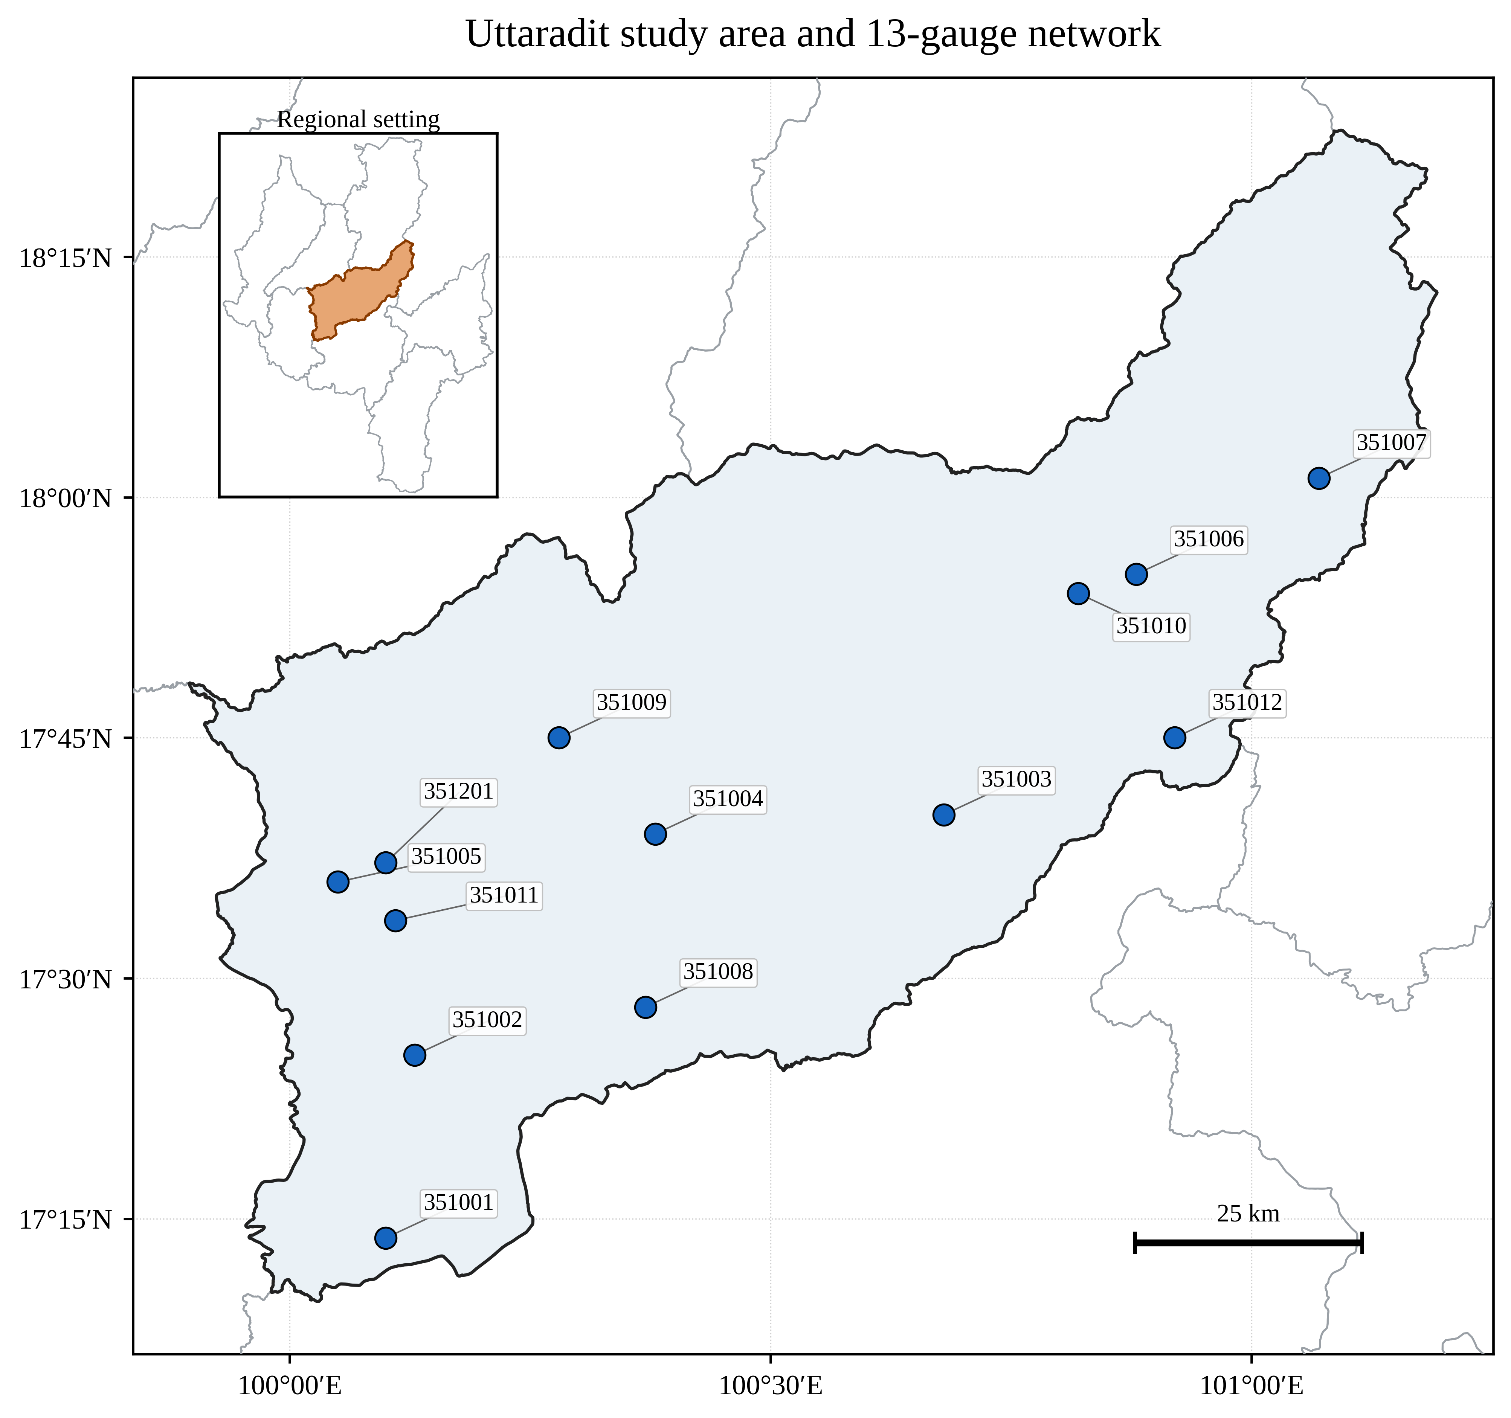
Figure 1. Study area and 13-gauge network in Uttaradit Province. Gauge coordinates and elevations were supplied with the daily rainfall archive.

2.2 Independent code and data audit
The source archives were hashed, and their internal input files and generated tables were inventoried. Index calculations were independently reimplemented from the daily CSV files rather than accepted from the archived spreadsheets. The independent implementation reproduced the archived legacy regional results when the same observed baseline (1981–2014), overlapping 30-year windows, station-percentage averaging, and ensemble mean were used. This established code-to-table traceability.
The audit then identified three issues relevant to inference. First, the archived near (2021–2050) and mid (2041–2070) windows overlap during 2041–2050; they are usable as climatologies but not as independent period contrasts. Second, future corrected values were compared directly with observed index means despite non-negligible residual historical bias. Third, percentage changes in rare-count indices can be unstable. For example, an archived SSP5-8.5 late-century R50mm summary had a positive mean percentage change (+72.2%) even though the regional absolute change was negative (−0.83 days yr−1) and six of seven models agreed on a decrease. The revised estimand therefore used non-overlapping 20-year periods, model-consistent historical baselines, ensemble medians, and absolute units for R50mm. This revision reinterprets previously generated audited outputs; it does not introduce a new scenario, model, bias-correction run, or resampling experiment.
The supplied trend module failed its own AR(1) null self-test, and an independent Monte Carlo audit likewise showed false-positive rates well above the nominal 0.05 level (Supplementary Note S1). Archived trend p-values were therefore excluded. Model sign agreement is reported as a descriptive robustness screen, not statistical significance. The original methods were consulted only to identify the intended tests [18,19].

2.3 Precipitation-extreme indices
A wet day was defined as daily precipitation greater than or equal to 1 mm. Station-specific 95th and 99th percentile thresholds were calculated from all observed wet days during 1981–2014 and then held fixed for observed and model calculations. Spells and rolling 5-day totals were reset at each calendar-year boundary. The 11 indices are ETCCDI or ETCCDI-style measures [4,5] and are defined in Table 1. R50mm is a study-specific fixed-threshold count and is not part of the core ETCCDI set.
Table 1. Definitions of the 11 annual precipitation-extreme indices.
Index | Unit | Definition
PRCPTOT | mm yr⁻¹ | Annual wet-day precipitation total (daily precipitation >= 1 mm)
SDII | mm wet-day⁻¹ | Mean precipitation on wet days
Rx1day | mm | Annual maximum 1-day precipitation
Rx5day | mm | Annual maximum consecutive 5-day precipitation
CDD | days | Annual maximum consecutive days with precipitation < 1 mm
CWD | days | Annual maximum consecutive days with precipitation >= 1 mm
R10mm | days yr⁻¹ | Annual count of days with precipitation >= 10 mm
R20mm | days yr⁻¹ | Annual count of days with precipitation >= 20 mm
R50mm | days yr⁻¹ | Annual count of days with precipitation >= 50 mm
R95p | mm yr⁻¹ | Annual precipitation above the observed wet-day 95th percentile
R99p | mm yr⁻¹ | Annual precipitation above the observed wet-day 99th percentile

Note: R50mm is study-specific; the remaining measures follow ETCCDI or ETCCDI-style definitions. Wet days have precipitation ≥1 mm.

2.4 Historical performance and residual bias
Raw and corrected historical simulations were aligned with observations at each model–gauge pair. Daily and monthly performance was summarized by Pearson correlation (r), root mean squared error (RMSE), mean absolute error (MAE), percentage bias (PBIAS), Nash–Sutcliffe efficiency (NSE), and Kling–Gupta efficiency (KGE). Taylor-style correlation and variability diagnostics are useful summaries [9], but bias- and error-sensitive diagnostics were retained because no single metric establishes precipitation skill [7,10]. Results are medians and interquartile ranges across 91 model–gauge pairs.
Residual bias was calculated for each index over 1995–2014 as the bias-corrected historical mean minus the observed mean. This recent-climate interval is consistent with the 1995–2014 reference used in IPCC AR6 [1] and also gives the historical and future climatological summaries equal 20-year duration. Raw-to-corrected change-signal preservation was evaluated for every model, scenario, period, and index by comparing each future period with the corresponding raw or corrected 1995–2014 model baseline.

2.5 Projection estimands and robustness
The near-, mid-, and long-term periods were 2021–2040, 2041–2060, and 2081–2100, respectively. These equal-length, non-overlapping windows provide distinct climatological snapshots and remove the shared years in the archived 30-year near- and mid-term windows. Twenty years is shorter than the conventional 30-year climate normal and therefore more sensitive to internal variability; the windows are used for descriptive scenario comparison, not formal trend inference. For model m, station s, index k, scenario q, and future period w, the primary absolute change was
Δmodel = mean(BC futurem,s,k,q,w) − mean(BC historicalm,s,k,1995–2014).
The sensitivity estimand replaced the model historical term with the observed station mean for 1995–2014. Relative changes were calculated after first averaging the 13 stations for each model, thereby avoiding disproportionate weight from stations with small denominators. The multimodel central estimate was the median of seven model-level regional changes; the 25th–75th percentile range described spread. A change was classified as a robust increase or decrease when at least six of seven models agreed on its sign. Six of seven (85.7%) is the first attainable integer count that satisfies the prespecified ≥80% criterion and is deliberately stricter than a simple majority. Other combinations were classified as ambiguous. This screen is not a statistical test, and the effective evidence may be smaller than seven because no model-independence weighting was available [11]. The complete 66-combination baseline comparison is provided in Supplementary Table S1.

3. Results

3.1 Historical performance and residual bias
Bias correction improved some but not all aspects of historical performance (Table 2). At the daily model–gauge scale, median PBIAS improved from −21.9% to −9.0%, correlation rose from 0.037 to 0.057, and KGE rose from −0.120 to 0.012. However, median daily RMSE increased from 10.18 to 11.84 mm day−1, and only 8.8% of model–gauge pairs had lower RMSE after correction. At monthly scale, median correlation increased from 0.272 to 0.441 and KGE from 0.162 to 0.385, while RMSE increased from 103.98 to 108.73 mm month−1. Across both scales, absolute PBIAS improved for 67.0% of pairs; KGE improved for 85.7%. Thus, correction improved mean bias and integrated monthly behavior more consistently than day-to-day timing or error magnitude; no single metric supports an unqualified claim of correction success.
Table 2. Median historical performance across 91 model–gauge pairs for raw and supplied bias-corrected series.
Scale | Series | r | RMSE | PBIAS (%) | NSE | KGE
Daily | Raw | 0.037 | 10.18 mm d⁻¹ | -21.9 | -0.353 | -0.120
Daily | Bias-corrected | 0.057 | 11.84 mm d⁻¹ | -9.0 | -0.968 | 0.012
Monthly | Raw | 0.272 | 103.98 mm month⁻¹ | -21.9 | -0.308 | 0.162
Monthly | Bias-corrected | 0.441 | 108.73 mm month⁻¹ | -9.0 | -0.344 | 0.385

Note: monthly RMSE is for monthly rainfall totals and daily RMSE is for daily rainfall. Lower RMSE and |PBIAS| are better; higher r, NSE, and KGE are better.
Historical correction did not eliminate index-specific errors. Across the seven model-level regional summaries for 1995–2014, median residual bias was +29.6% for CDD, −64.1% for CWD, +18.0% for SDII, +14.7% for Rx5day, +22.1% for R95p, and +20.7% for R99p. PRCPTOT residual bias was smaller (median −5.3%) but varied across models sufficiently to affect some change estimates. These errors explain why a future-versus-observed contrast can mix model bias with simulated climate change. Extended performance and residual-bias summaries are reported in Supplementary Tables S2–S3.

3.2 Sensitivity to baseline and correction
Baseline selection materially altered the result (Figure 2; Supplementary Table S1). Of 66 scenario–period–index combinations, 25 (37.9%) changed sign when the observed baseline was replaced by the model-consistent historical baseline. The three-class label (robust increase, robust decrease, or ambiguous) changed for 37 combinations (56.1%). These frequencies are descriptive sensitivity results, not hypothesis-test outcomes. The largest departures were associated with large residual biases in CWD, CDD, R20mm, R95p, and R99p. R50mm required separate reporting in absolute units because its small count baselines made percentages unstable.
Bias correction also modified the modeled change signal. Across 462 model–scenario–period–index cases, raw and corrected changes had the same sign in 66.9% of cases. The median absolute difference between their relative changes was 12.1 percentage points. This diagnostic does not by itself prove an error in correction, because fixed-threshold and spell indices can respond nonlinearly to distributional adjustment. It does show that change preservation could not be assumed from the file label alone.
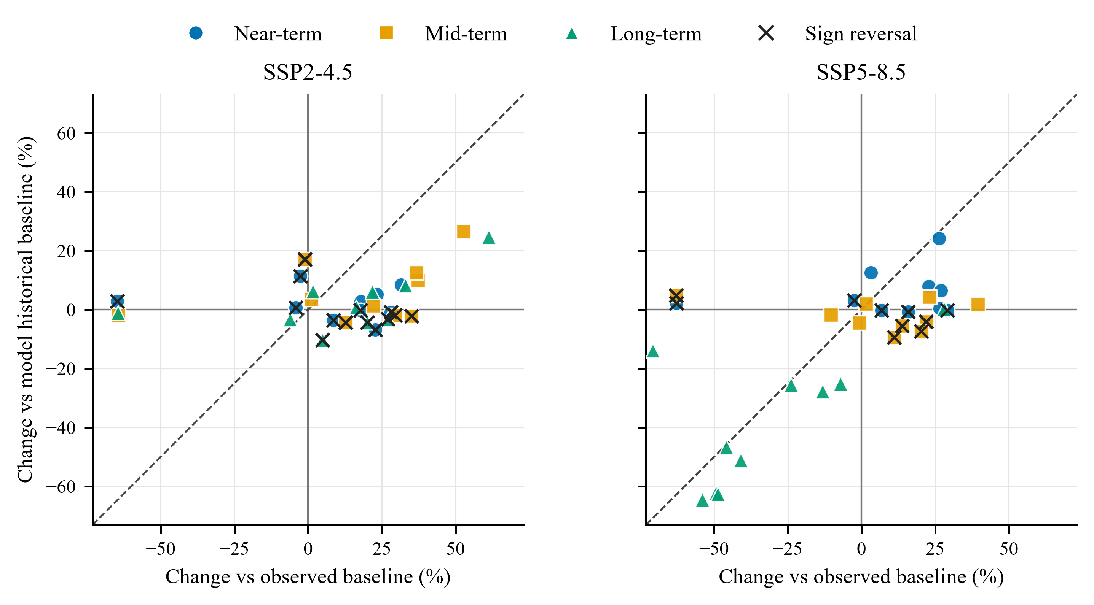
Figure 2. Sensitivity of regional median relative changes to baseline source. The x-axis uses observations for 1995–2014; the y-axis uses each model's supplied bias-corrected historical series for 1995–2014. Colors and symbols distinguish projection periods. Each point is an index–period combination; R50mm is excluded because percentage changes are unstable at small baselines. Crosses mark sign reversals and the dashed line is 1:1. Results are descriptive rather than significance tests.

3.3 Audited future changes
The model-consistent results did not support a monotonic province-wide increase in precipitation extremes (Figures 3 and 4; Table 3). Under SSP2-4.5, all near-term indices were ambiguous. In the mid-term, six of seven models supported increases in Rx5day (+12.5%; interquartile range 7.5–27.4%), R95p (+9.9%; 1.5–27.6%), and R99p (+26.5%; 8.4–55.4%). R50mm increased by a median 0.65 days yr−1 (0.18–1.06 days yr−1); its +30.8% relative value is secondary because of denominator sensitivity. SSP2-4.5 long-term changes were ambiguous for all 11 indices.
Under SSP5-8.5, the near-term signal was also mostly ambiguous; only CWD showed a small robust increase (+0.27 days, +2.2%). The mid-term showed robust but modest reductions in PRCPTOT (−1.9%), SDII (−5.5%), R10mm (−4.5%), and R20mm (−9.4%). By 2081–2100, the ensemble showed a broad and internally consistent reduction in wet-day amount, frequency, and upper-tail totals: PRCPTOT −46.7%, SDII −27.7%, Rx1day −25.6%, Rx5day −25.2%, R95p −64.5%, R99p −62.6%, R10mm −51.1%, R20mm −62.2%, and CWD −14.0%. R50mm decreased by 1.18 days yr−1. For PRCPTOT, the median across the seven models was first calculated separately at each gauge; the range of these 13 station-level medians was −51.6% to −27.3%, and all seven models agreed on a decrease at every gauge. In contrast, CDD remained ambiguous at regional and station scales. The result is therefore a robust reduction in modeled rainfall amount and wet-event metrics, not evidence of a robust increase in maximum dry-spell length.
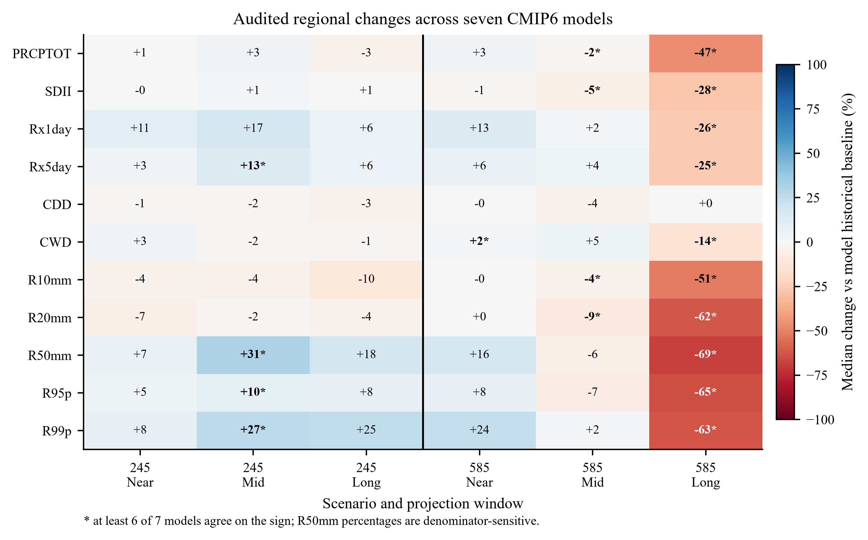
Figure 3. Audited multimodel regional median relative changes from the model-consistent baseline. Values are percentages; an asterisk indicates that at least six of seven models agreed on direction. R50mm percentages are shown only for completeness and are denominator-sensitive. The full model-consistent and observed-reference comparison is in Supplementary Table S1.
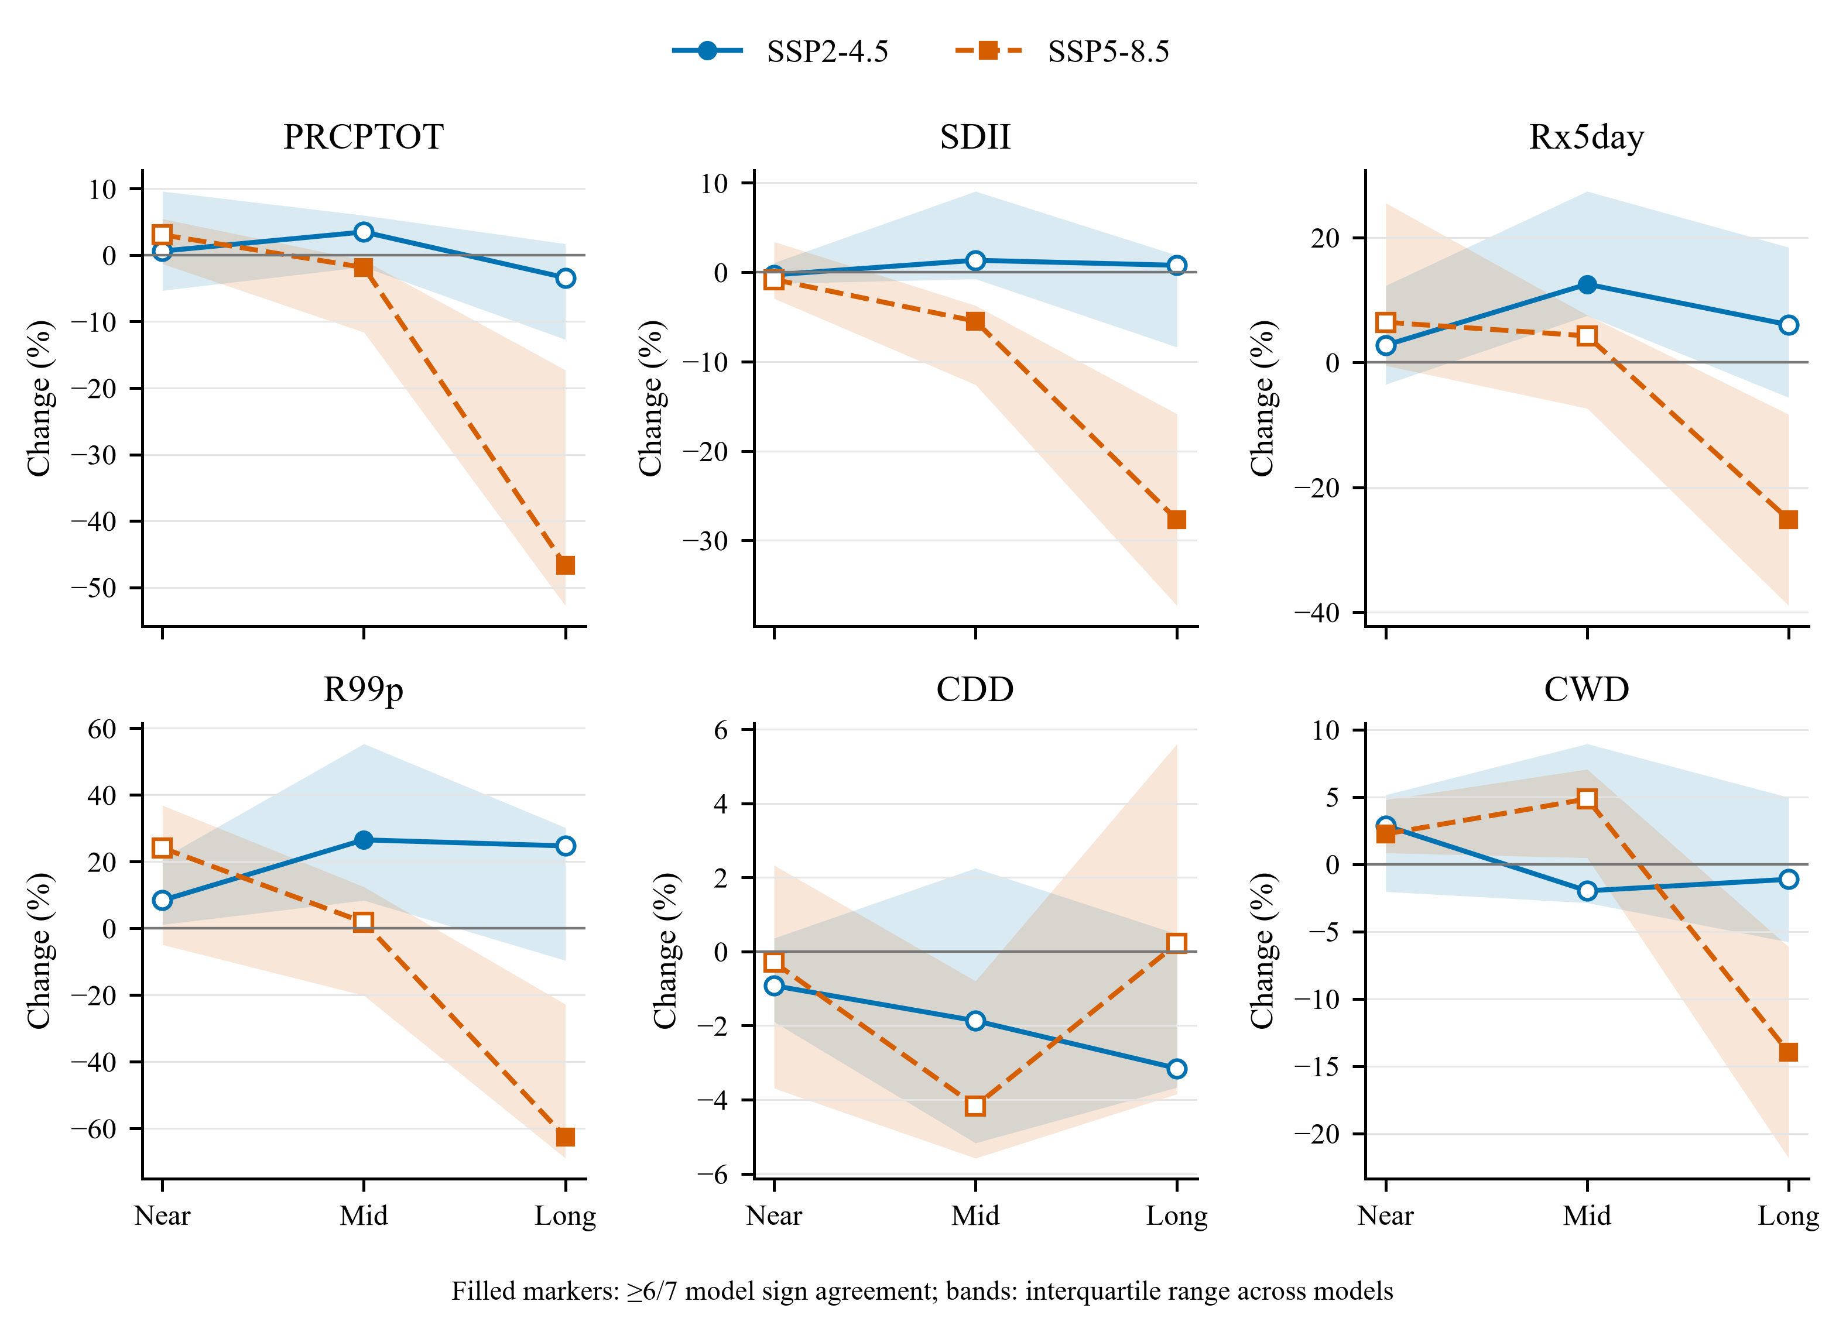
Figure 4. Selected model-consistent projection profiles. Points show seven-model medians and bands show interquartile ranges. Filled markers indicate agreement by at least six of seven models; open markers are ambiguous. Colors distinguish scenarios.
Table 3. Selected robust multimodel regional changes from the model-consistent baseline.
Scenario | Period | Index | Median change (IQR) | Models
SSP2-4.5 | 2041–2060 | Rx5day | +12.5 (+7.5 to +27.4)% | 6/7
SSP2-4.5 | 2041–2060 | R99p | +26.5 (+8.4 to +55.4)% | 6/7
SSP2-4.5 | 2041–2060 | R50mm | +0.65 (+0.18 to +1.06) d yr⁻¹ | 6/7
SSP5-8.5 | 2041–2060 | PRCPTOT | -1.9 (-11.6 to -0.8)% | 6/7
SSP5-8.5 | 2041–2060 | SDII | -5.5 (-12.6 to -3.7)% | 6/7
SSP5-8.5 | 2081–2100 | PRCPTOT | -46.7 (-52.8 to -17.3)% | 7/7
SSP5-8.5 | 2081–2100 | SDII | -27.7 (-37.3 to -15.9)% | 7/7
SSP5-8.5 | 2081–2100 | Rx5day | -25.2 (-39.0 to -8.3)% | 6/7
SSP5-8.5 | 2081–2100 | R99p | -62.6 (-69.0 to -22.8)% | 6/7
SSP5-8.5 | 2081–2100 | CWD | -14.0 (-21.8 to -6.2)% | 6/7
SSP5-8.5 | 2081–2100 | R50mm | -1.18 (-1.53 to -0.56) d yr⁻¹ | 6/7

Note: IQR is the interquartile range across seven model-level regional changes. Six of seven models (85.7%) is the first integer count satisfying the prespecified ≥80% sign-agreement criterion; this is descriptive, not a significance test. R50mm is reported in signed native units.

4. Discussion

4.1 Baseline definition is part of the scientific estimand
A future-versus-observed comparison answers an absolute consistency question: how does a model's future climatology compare with the observed past? When historical correction is imperfect, however, that contrast equals the model's simulated change plus residual historical bias. The model-consistent contrast better isolates the change carried by each corrected simulation. This distinction was consequential in Uttaradit because residual biases for spells and upper-tail indices were often larger than the projected near- and mid-century changes. The legacy R50mm example further showed that averaging station-level percentages can produce a sign opposite to the absolute regional change when denominators are small. Absolute units, regional ratios, and sign agreement should therefore be examined together.
These findings reinforce two methodological principles. First, bias correction should be evaluated out of sample and for the properties used in impact analysis, not only for mean rainfall. Free-running climate simulations are not phase-aligned with the observed sequence of individual events, so daily correlation and pointwise RMSE are not measures of event-prediction skill. Even so, the rise in RMSE alongside improved PBIAS and KGE demonstrates a trade-off among magnitude error, temporal correspondence, and distributional alignment rather than uniformly better corrected series. Daily distributions contain occurrence and tail behavior that monthly statistics can hide [7]. Residual CWD and CDD biases are consistent with unresolved wet-day occurrence or timing errors, including possible drizzle-type behavior, but unavailable occurrence-adjustment diagnostics prevent attribution to a specific mechanism. Second, future change preservation must be demonstrated. QDM is designed to preserve relative changes in model quantiles [8], but the supplied archive was insufficient to verify its calibration, and only two-thirds of derived index changes retained the raw-model sign. This is a diagnostic warning rather than a general evaluation of QDM because annual spells and threshold exceedances are nonlinear functions of daily rainfall.

4.2 Interpretation for Uttaradit
The audited projections describe two different projection patterns. Under SSP2-4.5, the most coherent signal was a mid-century intensification of multi-day and upper-tail rainfall without a robust change in annual wet-day total. This combination could matter for short-duration drainage and erosion planning, but no direct flood consequence can be inferred without catchment, soil, river, and exposure data. Under SSP5-8.5, the long-term result was a widespread reduction in total rainfall, wet-spell persistence, and heavy-rainfall totals. Because CDD was ambiguous, the result should not be translated into a claim of longer annual dry spells; it more directly indicates fewer and weaker modeled wet events.
The strong late-century SSP5-8.5 drying in this seven-model local archive differs from the broad IPCC assessment that heavy precipitation will increase over much of Asia [1]. Such a difference is not necessarily contradictory: IPCC statements cover large reference regions and calibrated lines of evidence, whereas the present analysis concerns one province, a small equal-weight ensemble, supplied corrected station series, and annual index summaries. Thailand studies have likewise shown substantial dependence on model, subregion, season, and period [12,13]. Moazzam et al. [14] found lower observed annual and monsoonal rainfall in 2003–2017 than in 1988–2002 across their eight-station Uttaradit study and raised drought concern using SPI and linear extrapolation. The SSP5-8.5 drying pattern is directionally consistent with that concern, but it does not validate the projection because the periods, estimands, and methods differ; notably, CDD remained ambiguous here. The local signal should therefore be treated as a scenario-conditioned stress test, not a replacement for regional assessment.
The results can inform the climate-information component of provincial planning. SSP2-4.5 mid-century upper-tail increases support testing preparedness for concentrated rainfall, while SSP5-8.5 late-century reductions support testing water-supply and agricultural systems against lower annual inflow and shorter wet spells. Thailand's National Adaptation Plan emphasizes science-based subnational risk information [20]. Translation to operational thresholds requires seasonal analyses and sector-specific response models beyond the scope of this study.

4.3 Evidence boundaries and limitations

4.3.1 Bias-correction provenance and threshold transfer
The correction algorithm, training period, wet-day occurrence treatment, extrapolation rule, and validation split were unavailable. Accordingly, the results evaluate supplied corrected series and must not be generalized to QDM as a method. Fixed observed 1981–2014 thresholds were used for R95p and R99p. Because threshold exceedance totals are nonlinear, subtraction of each model's corrected history does not guarantee cancellation of threshold-transfer bias. The results are specifically changes in observed-threshold exceedance totals within the supplied series; sensitivity to alternative threshold definitions was not evaluated.

4.3.2 Ensemble design and model dependence
The ensemble contained one realization from each of seven equally weighted models. Shared components or development histories could reduce the effective information below seven independent models [11], but the supplied archive contained no genealogy or dependence metadata from which to infer specific relationships. The 6/7 agreement count is therefore a transparent descriptive screen, not an independence-adjusted confidence measure or probability statement. Internal variability cannot be separated from model structural spread with one realization per model.

4.3.3 Spatial representation and pseudo-replication
The 13 station labels identify output locations but do not establish 13 independent model grid cells. Source-grid identifiers and extraction metadata were unavailable, and equality of corrected series would not reliably recover grid identity because station-specific correction can differentiate series originating from a common cell. Spatial findings are therefore equal-weight station-network summaries, not area-weighted provincial estimates or 13 independent model realizations.

4.3.4 Temporal scope, calendars, and statistical evidence
Only annual indices and three 20-year windows were considered; monsoon onset, cessation, seasonal risk windows, and sensitivity to other window lengths were not evaluated. Shorter-than-30-year windows remain sensitive to internal variability. Native calendars were retained without imputation, preserving within-model consistency while leaving slightly different annual exposure for accumulation, count, and spell indices across models. Finally, archived trend p-values were rejected after failed null diagnostics, and no bootstrap intervals were generated. Uncertainty is therefore represented only by model IQR and sign agreement, neither of which quantifies sampling probability or statistical significance.

5. Conclusion
Independent recomputation showed that the supplied workflow is traceable, but its headline conclusions are sensitive to residual bias, baseline source, overlapping windows, and percentage aggregation. Within non-overlapping AR6-style periods, replacing the observed reference with each model's corrected historical baseline changed the sign of 25/66 results and the robustness class of 37/66. The evidence supports a specific interpretation: SSP2-4.5 shows mid-century increases in selected multi-day and upper-tail indices, whereas SSP5-8.5 shows strong late-century reductions in rainfall amount, wet-day intensity, wet-spell duration, and heavy-rainfall totals; CDD is not robust. These are bounded, scenario-conditioned climate-hazard signals. Their magnitudes should not be treated as calibrated probabilities or generalized to QDM until the correction provenance and independent validation information are supplied.

6. Ethical Approval
Not applicable. This study used meteorological observations and climate-model simulations and did not involve human participants or animals.

7. Declaration of Generative AI and AI-Assisted Technologies in the Writing Process
During preparation of this manuscript, OpenAI Codex was used to assist with code auditing, verification of previously generated analytical outputs, refinement of visualizations, document formatting, and language editing. The authors are responsible for verifying the final scientific content, declarations, references, and submitted version. [Author confirmation required before submission.]

8. Acknowledgements
[Author input required: identify data providers and facilities, and provide the funding agency and grant number or state that no specific funding was received.]

9. Author Contributions
[Author input required: insert verified CRediT roles for every named author. Do not assign roles until the author list is confirmed.]

10. Conflicts of Interest
[Author confirmation required: declare all competing interests or state that the authors have no competing interests.]

11. Data and Code Availability
The observations, model series, source code, and archived outputs used in this study were supplied by the study authors. No public repository identifier, access conditions, or complete bias-correction provenance were available for this revision. [Before submission, the corresponding author must provide a repository URL/DOI or a justified access statement, the software environment, and the correction provenance.] The accompanying Supplementary Information reports the full 66-combination baseline-sensitivity table, extended historical-skill and residual-bias summaries, and the trend-module null diagnostic.

12. References
1. IPCC. Climate Change 2021: The Physical Science Basis. Contribution of Working Group I to the Sixth Assessment Report of the Intergovernmental Panel on Climate Change. Masson-Delmotte V, Zhai P, Pirani A, Connors SL, Péan C, Berger S, et al., editors. Cambridge: Cambridge University Press; 2021. doi:10.1017/9781009157896.
2. Eyring V, Bony S, Meehl GA, Senior CA, Stevens B, Stouffer RJ, et al. Overview of the Coupled Model Intercomparison Project Phase 6 (CMIP6) experimental design and organization. Geosci Model Dev. 2016;9:1937-1958. doi:10.5194/gmd-9-1937-2016.
3. O'Neill BC, Tebaldi C, van Vuuren DP, Eyring V, Friedlingstein P, Hurtt G, et al. The Scenario Model Intercomparison Project (ScenarioMIP) for CMIP6. Geosci Model Dev. 2016;9:3461-3482. doi:10.5194/gmd-9-3461-2016.
4. Zhang X, Alexander L, Hegerl GC, Jones P, Klein Tank AMG, Peterson TC, et al. Indices for monitoring changes in extremes based on daily temperature and precipitation data. Wiley Interdiscip Rev Clim Change. 2011;2:851-870. doi:10.1002/wcc.147.
5. Donat MG, Alexander LV, Yang H, Durre I, Vose R, Dunn RJH, et al. Updated analyses of temperature and precipitation extreme indices since the beginning of the twentieth century: the HadEX2 dataset. J Geophys Res Atmos. 2013;118:2098-2118. doi:10.1002/jgrd.50150.
6. Tung YS, Wang CY, Weng SP, Yang CD. Extreme index trends of daily gridded rainfall dataset (1960-2017) in Taiwan. Terr Atmos Ocean Sci. 2022;33:8. doi:10.1007/s44195-022-00009-z.
7. Martinez-Villalobos C, Neelin JD, Pendergrass AG. Metrics for evaluating CMIP6 representation of daily precipitation probability distributions. J Clim. 2022;35:5719-5743. doi:10.1175/JCLI-D-21-0617.1.
8. Cannon AJ, Sobie SR, Murdock TQ. Bias correction of GCM precipitation by quantile mapping: how well do methods preserve changes in quantiles and extremes? J Clim. 2015;28:6938-6959. doi:10.1175/JCLI-D-14-00754.1.
9. Taylor KE. Summarizing multiple aspects of model performance in a single diagram. J Geophys Res Atmos. 2001;106:7183-7192. doi:10.1029/2000JD900719.
10. Gupta HV, Kling H, Yilmaz KK, Martinez GF. Decomposition of the mean squared error and NSE performance criteria: implications for improving hydrological modelling. J Hydrol. 2009;377:80-91. doi:10.1016/j.jhydrol.2009.08.003.
11. Knutti R, Sedláček J, Sanderson BM, Lorenz R, Fischer EM, Eyring V. A climate model projection weighting scheme accounting for performance and interdependence. Geophys Res Lett. 2017;44:1909-1918. doi:10.1002/2016GL072012.
12. Supharatid S, Aribarg T, Nafung J. Bias-corrected CMIP6 climate model projection over Southeast Asia. Theor Appl Climatol. 2022;147:669-690. doi:10.1007/s00704-021-03844-1.
13. Tangang F, Santisirisomboon J, Juneng L, Salimun E, Chung JX, Supari, et al. Projected future changes in mean precipitation over Thailand based on multi-model regional climate simulations of CORDEX Southeast Asia. Int J Climatol. 2019;39:5413-5436. doi:10.1002/joc.6163.
14. Moazzam MFU, Lee BG, Rahman G, Waqas T. Spatial rainfall variability and an increasing threat of drought, according to climate change in Uttaradit Province, Thailand. Atmos Clim Sci. 2020;10:357-371. doi:10.4236/acs.2020.103020.
15. de Oliveira-Júnior JF, Mendes D, Porto HD, Cardoso KRA, Ferreira Neto JA, da Silva EBC, et al. Analysis of drought and extreme precipitation events in Thailand: trends, climate modeling, and implications for climate change adaptation. Sci Rep. 2025;15:4501. doi:10.1038/s41598-025-86826-x.
16. Leerach K, Iamchuen N, Thanawong K, Busababodhin P, Kirtsaeng S, Pimonsree S. Meso-scale spatiotemporal analysis of future drought characteristics in Northern Thailand under climate change and variability. Theor Appl Climatol. 2025;156:439. doi:10.1007/s00704-025-05662-1.
17. Sittichok K, Kuntiyawichai K, Narudeesri-utai R. Extreme rainfall trends and return periods under CMIP6 scenarios in Southern Thailand. Water Sci. 2026;40:51. doi:10.1007/s44533-026-00050-8.
18. Hamed KH, Rao AR. A modified Mann-Kendall trend test for autocorrelated data. J Hydrol. 1998;204:182-196. doi:10.1016/S0022-1694(97)00125-X.
19. Yue S, Pilon P, Phinney B, Cavadias G. The influence of autocorrelation on the ability to detect trend in hydrological series. Hydrol Process. 2002;16:1807-1829. doi:10.1002/hyp.1095.
20. Government of Thailand. Thailand's National Adaptation Plan. Bangkok: Department of Climate Change and Environment; 2024. Available from: https://unfccc.int/documents/638001.

